CYBERSECURITY INTERNSHIP
Organization name:- Elevate labs

Student Name:- Mansur Hussain Syed
University:- Aditya University
Domain:- Cybersecurity
Duration:- 1st January 2026 to 30th April 2026

TASK-7:- Web Application Vulnerability Testing

- OWASP Top 10 Vulnerabilities :-
The OWASP Top 10 is a globally recognized document published by the Open Web Application Security Project (OWASP). It identifies the most critical security risks to web applications based on real-world data, impact, and exploitability. It helps developers, testers, and security professionals understand and prevent common web attacks.

Broken Access Control
Broken Access Control occurs when applications fail to properly restrict what authenticated users are allowed to do. Attackers can access unauthorized data or perform restricted actions such as viewing other users’ data or gaining administrative privileges.

Cryptographic Failures
This vulnerability arises when sensitive data like passwords, credit card numbers, or personal information is not properly encrypted or protected. Weak encryption algorithms, poor key management, or transmitting data in plain text can lead to data exposure.

Injection
Injection flaws occur when untrusted user input is sent to an interpreter without proper validation. Common examples include SQL injection and command injection. Attackers can manipulate queries to access, modify, or delete data.

Insecure Design
Insecure Design refers to fundamental design flaws in an application’s architecture. These issues cannot be fixed by implementation alone.
Examples include lack of rate limiting, weak business logic, or absence of threat modeling during development.

Security Misconfiguration
Security Misconfiguration happens when systems are configured insecurely. This includes using default credentials, unnecessary open ports, verbose error messages, or improperly configured cloud services, making systems easy targets.

Vulnerable and Outdated Components
Applications often rely on third-party libraries and frameworks. If these components contain known vulnerabilities and are not updated, attackers can exploit them to compromise the application.

Identification and Authentication Failures
This vulnerability involves weak authentication mechanisms such as poor password policies, improper session management, or missing multi-factor authentication. It allows attackers to impersonate legitimate users.

Software and Data Integrity Failures
This occurs when applications do not verify the integrity of software updates, libraries, or data. Attackers can introduce malicious code through compromised updates or CI/CD pipelines, leading to supply-chain attacks.

Security Logging and Monitoring Failures
When applications fail to log security events or monitor suspicious activities, attacks may go undetected. This delays incident response and increases damage during breaches.

Server-Side Request Forgery (SSRF)
SSRF occurs when a server is tricked into making unauthorized requests to internal or external systems. Attackers can access internal services, cloud metadata, or sensitive resources not intended to be exposed.

- Setup vulnerable app (DVWA / Juice Shop) Vulnerable applications are intentionally insecure platforms used for learning, testing, and understanding web application vulnerabilities, especially the OWASP Top 10. Two widely used platforms are DVWA (Damn Vulnerable Web Application) and OWASP Juice Shop.

DVWA (Damn Vulnerable Web Application)
DVWA is a PHP/MySQL-based web application designed to help students and security professionals understand common web vulnerabilities in a controlled lab environment.

DVWA runs on a local web server stack. Once the server environment is installed:
    - DVWA files are placed inside the web server directory
    - Database configuration is set in a config file
    - The application initializes its own database
    - Security levels (Low, Medium, High) can be configured

Purpose of DVWA
    - Demonstrates vulnerabilities such as SQL Injection, XSS, CSRF, File Inclusion
    - Helps understand how vulnerabilities exist, not how to exploit
STEP 1: Install required packages Give command as sudo apt update
sudo apt install apache2 mariadb-server php php-mysqli php-gd git -y
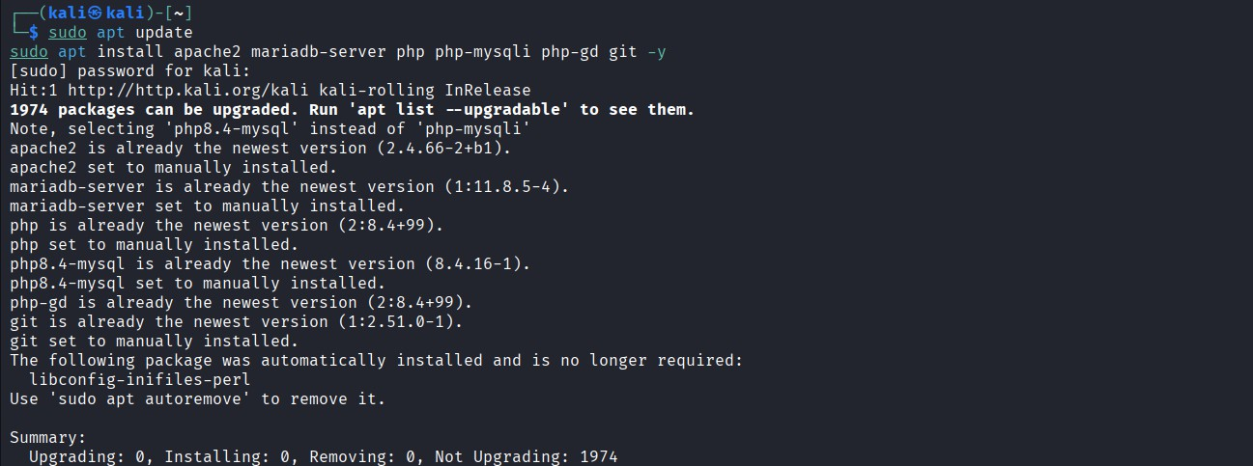

STEP 2: Start & enable services
sudo systemctl start apache2 mariadb sudo systemctl enable apache2 mariadb
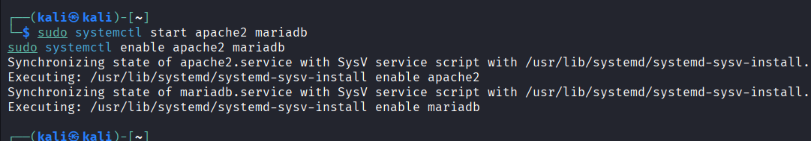
Check:
systemctl status apache2 systemctl status mariadb
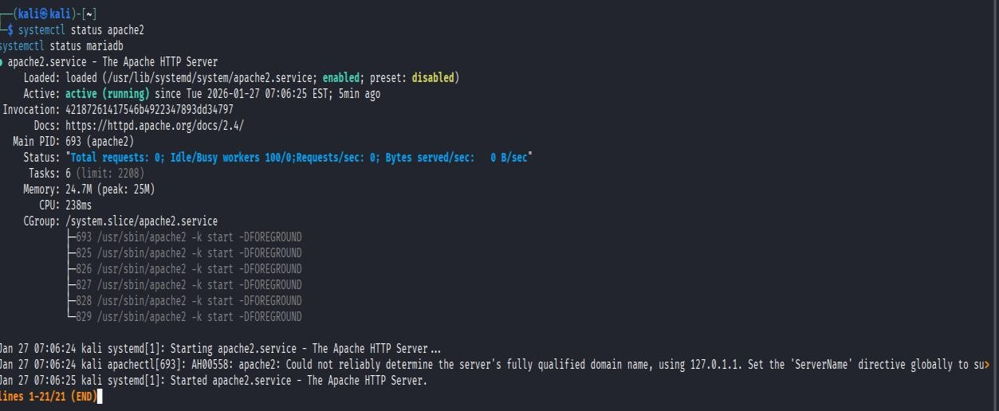

STEP 3: Download DVWA
cd /var/www/html
sudo git clone https://github.com/digininja/DVWA.git
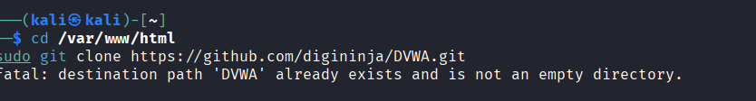

STEP 4: Create database & user (IMPORTANT)
sudo mysql Inside MariaDB:
CREATE DATABASE dvwa;
CREATE USER 'dvwa'@'localhost' IDENTIFIED BY 'dvwa'; GRANT ALL PRIVILEGES ON dvwa.* TO 'dvwa'@'localhost'; FLUSH PRIVILEGES;
EXIT;
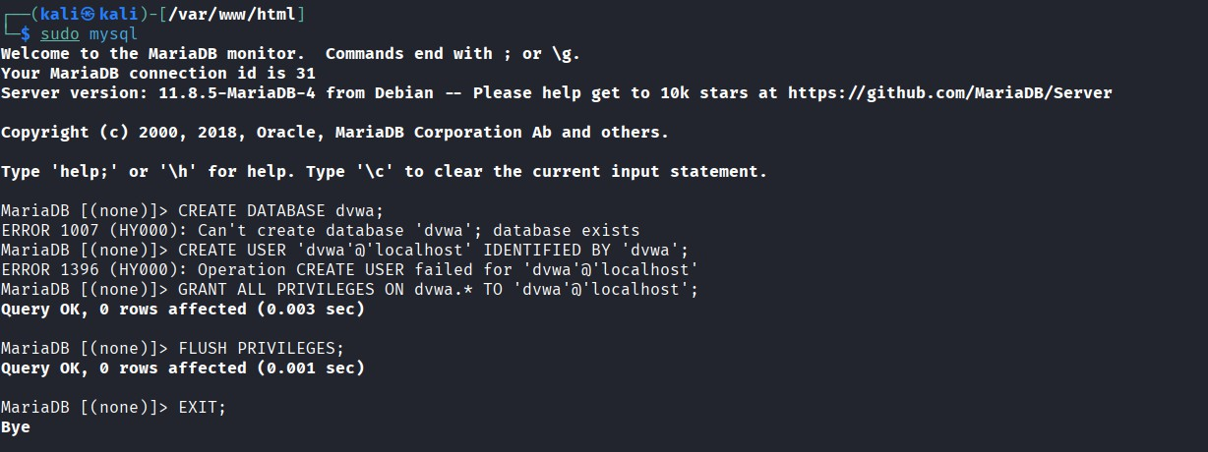

STEP 5: Configure DVWA
cd /var/www/html/DVWA/config
sudo cp config.inc.php.dist config.inc.php sudo nano config.inc.php

Edit ONLY these lines:
$_DVWA['db_user'] = 'dvwa';
$_DVWA['db_password'] = 'dvwa';

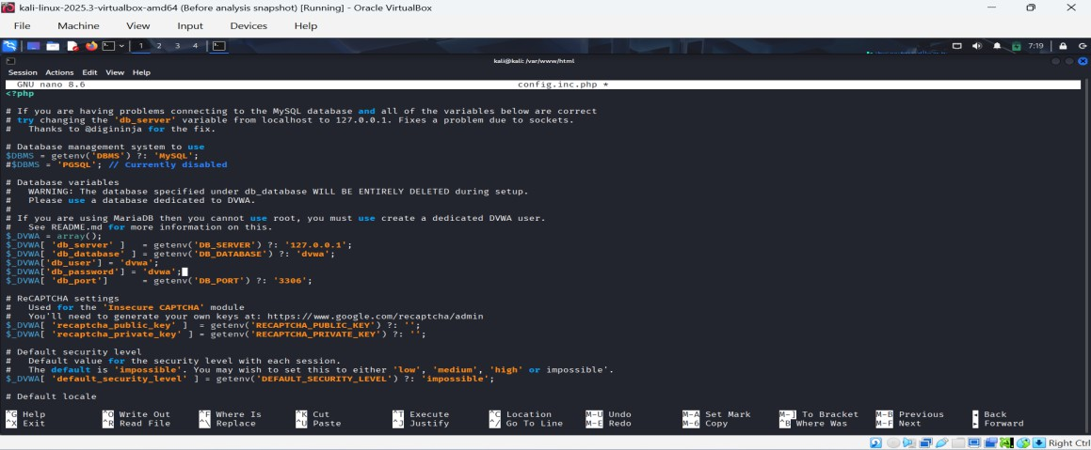

STEP 6: Fix permissions
sudo chown -R www-data:www-data /var/www/html/DVWA sudo chmod -R 755 /var/www/html/DVWA
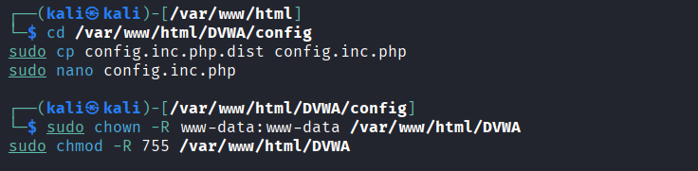

STEP 7: Enable Apache rewrite
sudo a2enmod rewrite
sudo nano /etc/apache2/apache2.conf Change:AllowOverride None to:AllowOverride All

Restart Apache:
sudo systemctl restart apache2
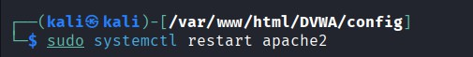

STEP 8: Create DVWA database (Browser)
Open browser: http://localhost/DVWA/setup.php
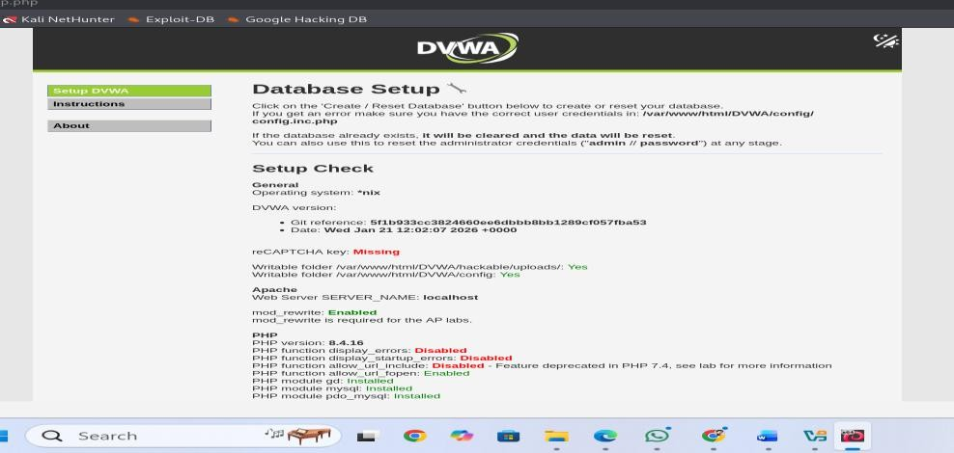

STEP 9: Login to DVWA
http://localhost/DVWA/login.php Credentials:
Username: admin Password: password
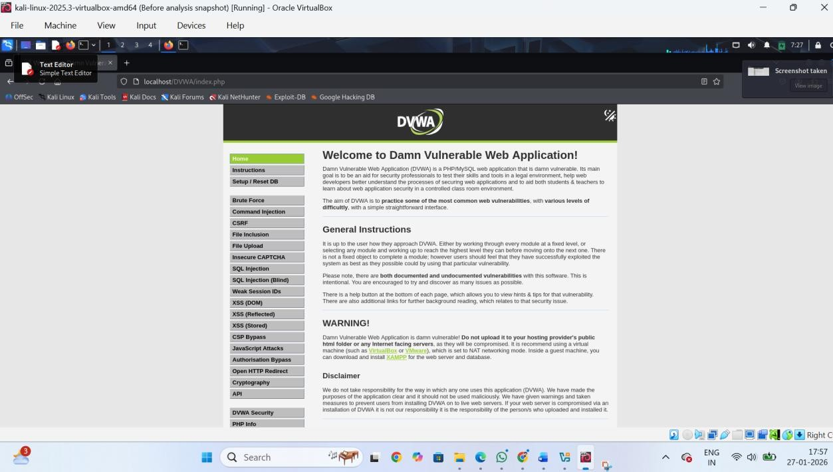

OWASP Juice Shop
OWASP Juice Shop is a modern vulnerable web application written in JavaScript (Node.js). It represents real-world application behavior and covers almost all OWASP Top 10 vulnerabilities.

Step 1: Install Docker
sudo apt update
sudo apt install docker.io -y sudo systemctl enable docker sudo systemctl start docker
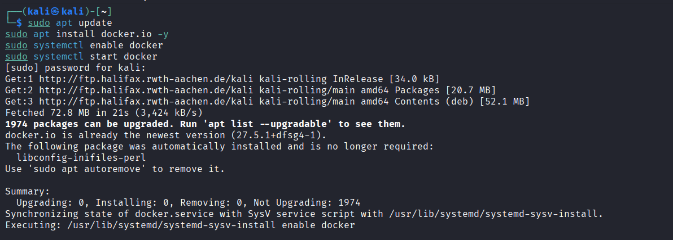
Add user to docker group:
sudo usermod -aG docker $USER newgrp docker

Step 2: Run Juice Shop
docker run --rm -p 3000:3000 bkimminich/juice-shop
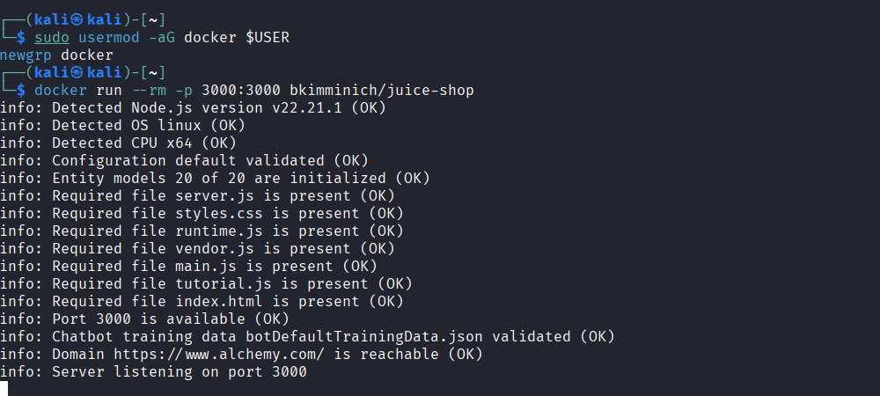

Step 3: Open browser
http://localhost:3000
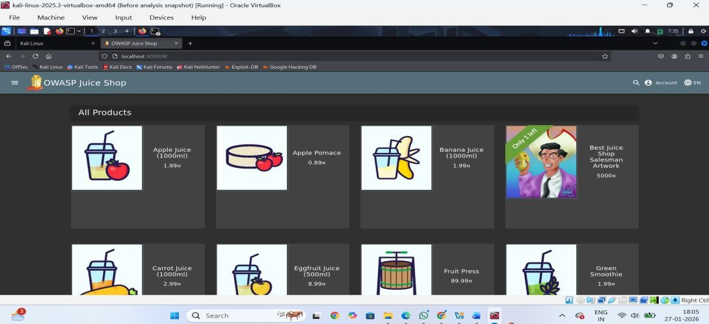

Intercept requests using Burp.
Burp Suite is a web application security testing tool used to:
- Intercept HTTP/HTTPS requests
- Modify requests before they reach the server
- Analyze responses
- Find vulnerabilities (SQLi, XSS, Auth bypass, IDOR, etc.)

STEP 1: Open Burp Suite (GUI)
- Click Applications → Web Application Analysis → Burp Suite
- Select Temporary Project
- Click Next → Start Burp

STEP 2: Open Burp Proxy Tab
- Click Proxy
- Click Intercept
- Ensure it shows: Intercept is ON
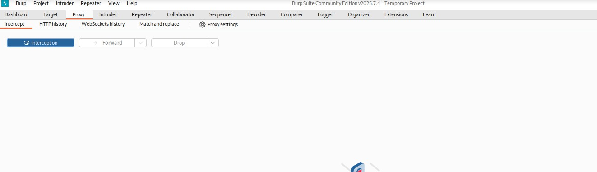

STEP 3: Configure Firefox Proxy (GUI)
Open Firefox
Click ☰ Menu → Settings Scroll → Network Settings Click Settings
Select Manual proxy configuration Enter:
HTTP Proxy: 127.0.0.1
Port: 8080
Tick Use this proxy for all protocols
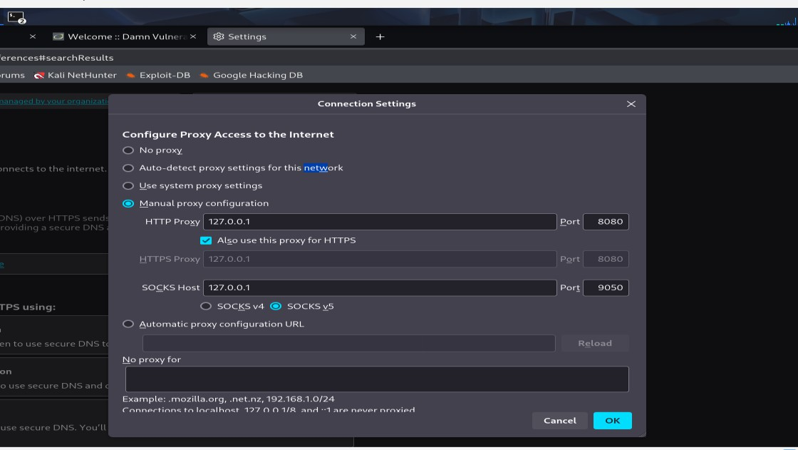

STEP 4: Open DVWA Login Page
In Firefox:http://localhost/DVWA/login.php Enter:Username: admin Password: password Click Login
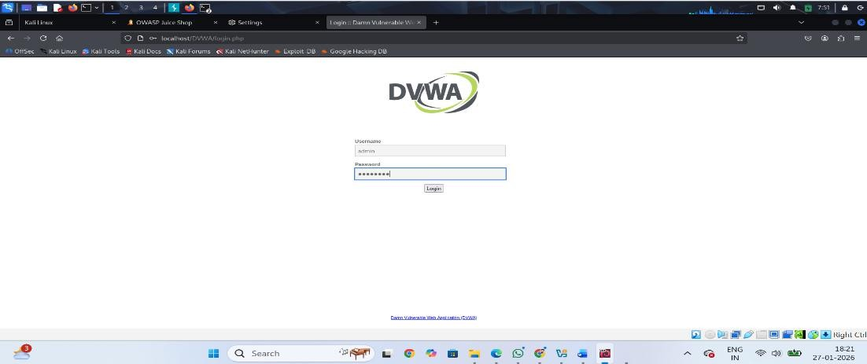

STEP 5: View Intercepted Request (GUI)
Switch to Burp Suite → Proxy → Intercept You will see a request like:
POST /DVWA/login.php HTTP/1.1 username=admin&password=password&Login=Login
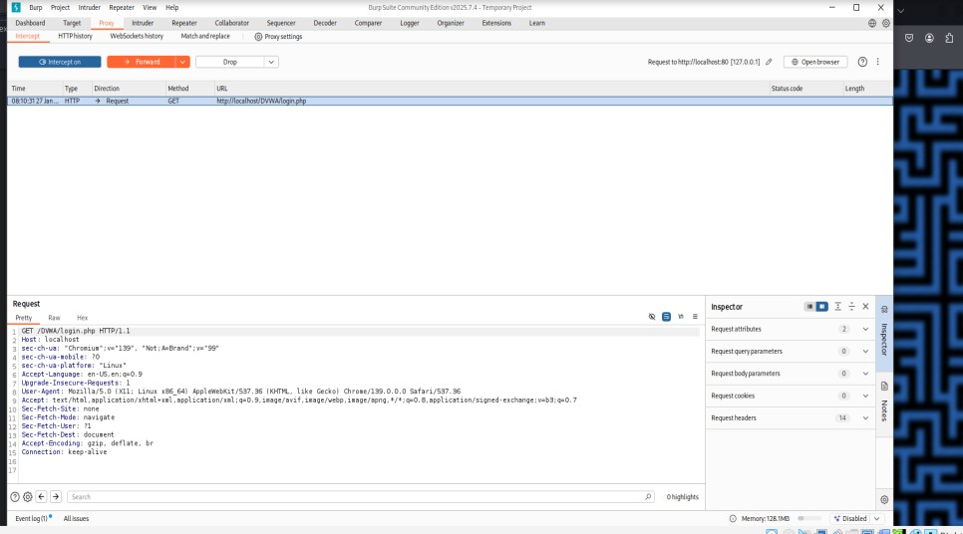

Test SQL Injection.
SQL Injection is a web application vulnerability where an attacker manipulates SQL queries by injecting malicious input into user-controlled fields (like login forms, search boxes, URLs).
Why SQL Injection Happens
- User input is directly concatenated into SQL queries
- No input validation or sanitization
- No prepared statements (parameterized queries)
- Poor error handling

STEP Login to DVWA Username: admin Password: password

STEP ⬛³ Set Security to LOW
  - Click DVWA Security
  - Set Security Level → LOW
  - Click Submit
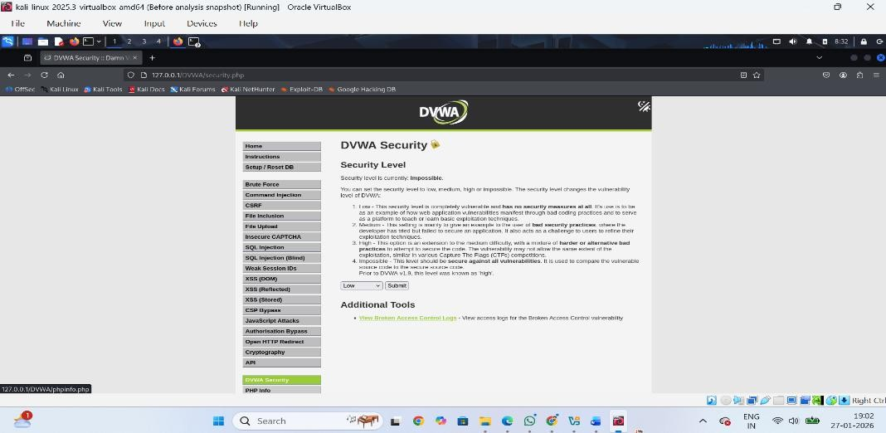

STEP Open SQL Injection Page
Go to:
DVWA → Vulnerabilities → SQL Injection
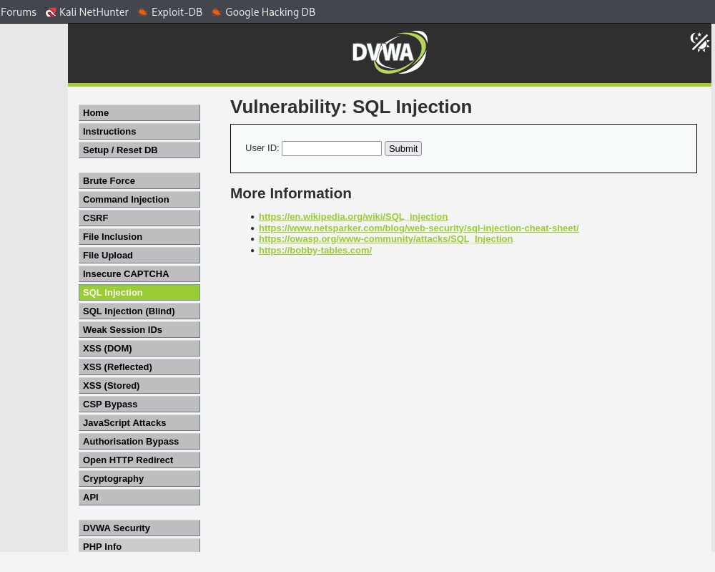

STEP Test Injection (Main Step)
In ID, enter:
1 OR 1=1
Click Submit
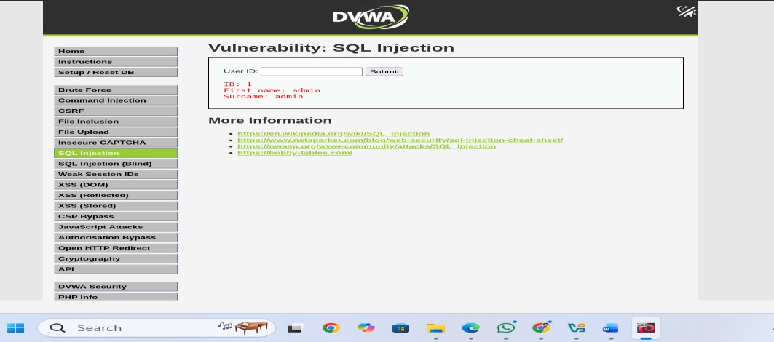
STEP ⬛³ Result (SUCCESS) All user records are displayed SQL Injection confirmed

Test XSS
XSS is a web vulnerability where an attacker injects malicious JavaScript into a web page, which then runs in another user’s browser.
Why XSS Happens
- No input validation
- User input is directly shown on web pages
- No output encoding
- No Content Security Policy (CSP)

STEP ⬛1 Login to DVWA
Username: admin Password: password

STEP Set DVWA Security to LOW
Click DVWA Security
Set Security Level → LOW
Click Submit
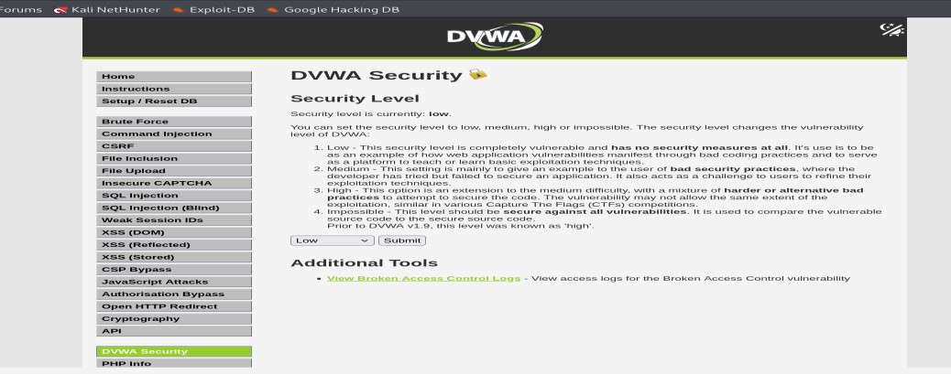

STEP Open XSS (Reflected)
Go to:
DVWA → Vulnerabilities → XSS (Reflected)
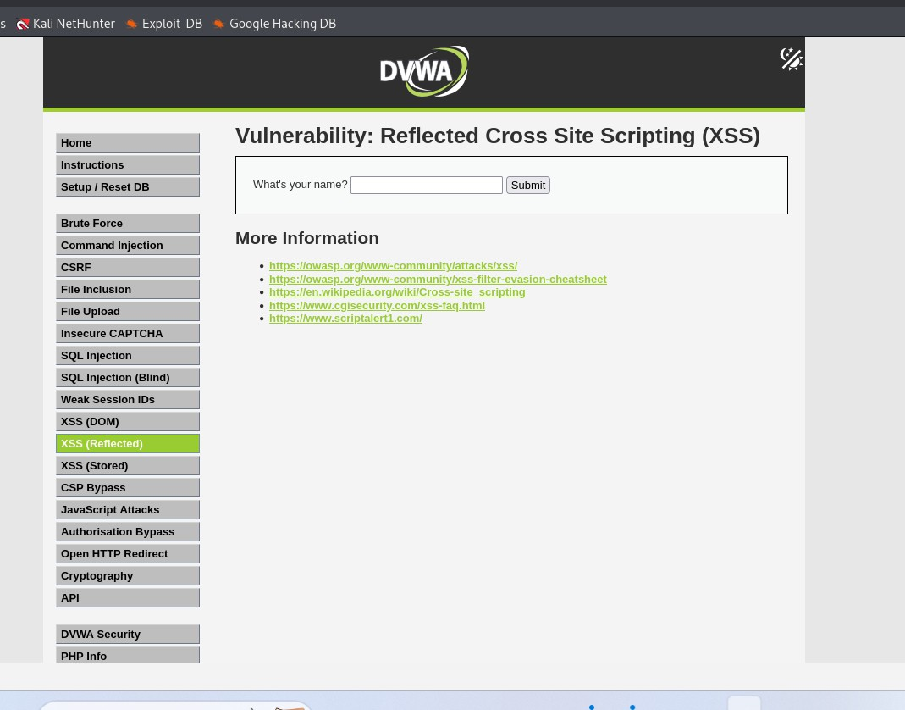

STEP Enter Test Payload
In input box, type:
<script>alert('XSS')</script> Click Submit

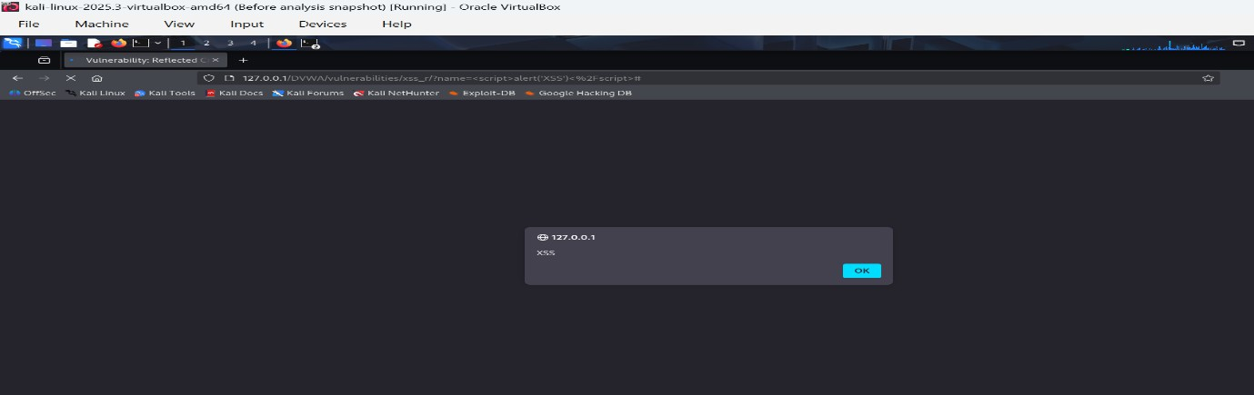
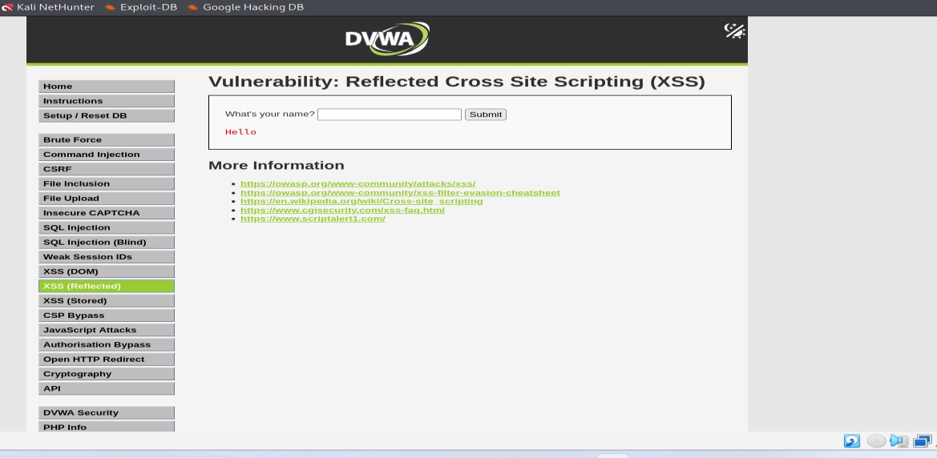

Observe Application Responses
During testing, application responses were carefully observed using Burp suite and the browser.

Observations for SQL Injection
- Application returned multiple database records for a single input.
- No input validation or sanitization was applied.
- SQL error messages or abnormal responses were visible.
- HTTP response code remained 200 OK even for malicious input.
- Database queries were modified by user input.

Conclusion:The application is vulnerable to SQL Injection due to improper handling of user input.

Observations for XSS
- Injected JavaScript executed successfully in the browser.
- Alert box popped up indicating script execution.
- Script was stored and executed for multiple users (Stored XSS).
- No output encoding was implemented.
- User input was directly reflected in the response.

Conclusion:
The application is vulnerable to Cross-Site Scripting (XSS).

Document Vulnerabilities
Vulnerability 1: SQL Injection
- Vulnerability Name is as : SQL Injection
- OWASP Category is as : A03 – Injection
- Affected Component: Login / ID input field
- Payload Use is as the following : 1' OR 1=1-- -

Result: Unauthorized access to database records. Impact: Data leakage will occur

Vulnerability 2: Cross-Site Scripting (XSS)
- Vulnerability Name: Stored / Reflected XSS
- OWASP Category: A07 – Cross-Site Scripting
- Affected Component: User input fields
- Payload Used:
- <script>alert('XSS')</script>
- Result: JavaScript executed in user’s browser.
- Impact: Session hijacking

Suggest Mitigations (Theory)
Suggesting mitigations involves recommending security measures to prevent or reduce the risk of identified vulnerabilities. Mitigations are based on secure coding and best security practices.

For SQL Injection, mitigations include:

- Using parameterized queries
- Validating and sanitizing user inputs
- Restricting database privileges
- Avoiding detailed error messages

For Cross-Site Scripting (XSS), mitigations include:

- Encoding output before displaying it
- Sanitizing user input

Conclusion
Observing responses, documenting vulnerabilities, and suggesting mitigations are essential phases of a secure web application testing process. These steps help in identifying weaknesses, understanding their impact, and strengthening the application against cyber attacks.

